

**OFFICE OF THE PRESIDENT**

**TO : ALL CONCERNED August 5, 2020**

**SUBJECT : CLASS DENSITY**

Greetings!

As approved by the School Board, we would like to inform you that the maximum class density for Academic Year 2020-2021 is **40** while the minimum is **35.**

Please strictly observe this directive.

Thank you for your attention and cooperation.

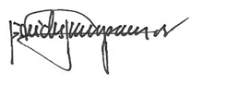

REV. FR. CRISTOPHER C. MASPARA, OAR

President

/bvs